STIA1123 Assignment 1
(Due Thursday 27 April 2015)

Answer all questions below. For every questions, you must submit a hardcopy and a softcopy of your source code (.java file). Also, in the hardcopy, print some sample outputs from the execution of your programs.
For the softcopy, email (attached) your zipped (compressed) source codes to my email => abuafiq@gmail.com. The name of your zipped file should be in the format below:
Asg1_101010.rar (if your matric number is 101010)
The subject of your email must be: STIA1123Asg1_101010 (if your matric number is 101010)
------------------------------------------------------------------------------------------------------------------------
Reminder: Each source code submitted must be the result of your own work. Copied source codes will earned you zero (0) mark.

1. An email address of a student is given in the form:
<name>@<school abbrev>.uum.edu.my
e.g. hakim@ibs.uum.edu.my
lokman@soc.uum.edu.my
soon_kiat@sois.uum.edu.my
siva@soa.uum.edu.my

Write a Java program that can read a student email address (in the above format) and display as output the name of the student and his/her complete school name. For example:

If the address is lokman@soc.uum.edu.my, the output will be:
Name: Lokman
School: School of Computing

If the address is soon_kiat@sois.uum.edu.my, the output will be:
Name: Soon_kiat
School: School of International Studies

Note:
Assume there are only 4 schools which are:
Abbreviation | School Name
ibs | Islamic Business School
soa | School of Accounting
soc | School of Computing
sois | School of International Studies

For the name, just display the name from the email but with the first letter capitalized.
If the address is not given in the described format above, output an appropriate error message.

Name of source code file to be submitted: Asg11.java

2. When a six-sided die is rolled, the number on the top face is between 1 and 6. Design and implement a class, called Die, to represent a die. The default constructor should initialize a die to the number 1. Your class must contain the method rollDie() that returns a random number between 1 and 6 (simulating the throwing of a die). Write a program that inputs an integer N (representing how many times to throw the die) and display as output how many times each of the number between 1 to 6 are generated from the N throws of the die.

Sample running 1:

Enter N> 10
No 1 = 2
No 2 = 1
No 3 = 1
No 4 = 1
No 5 = 2
No 6 = 3

Sample running 2:

Enter N> 10
No 1 = 1
No 2 = 0
No 3 = 2
No 4 = 3
No 5 = 2
No 6 = 2

Name of source code file to be submitted: Die.java
Asg12.java

3 a). Given below is the UML diagram for a Person class inheritance hierarchy:
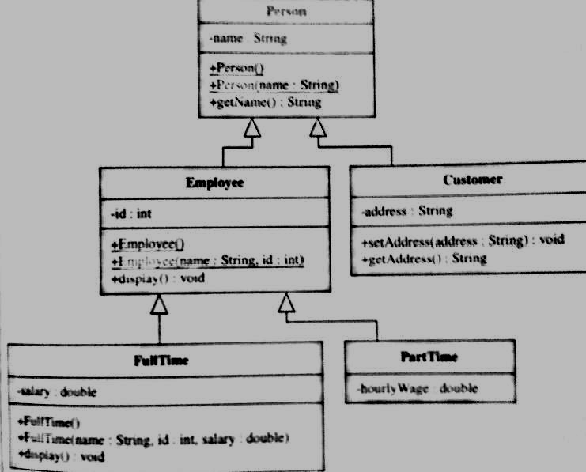

Write the definition of all five classes in the above UML diagram. The display() method for Employee object will print out the name and id of the Employee object. The display() method for FullTime object will print out the name,bid and salary of the FullTime object.

Write a test program named Asg13 that creates
i) a FullTime object and display his/her name , id and salary.
ii) a PartTime object and display his/her name and id.
In each case you must prompt the user to input all the needed values.

Name of source code file to be submitted: Person.java, Employee.java, Customer.java
FullTime.java, PartTime.java & Asg13a.java

3 b). The class Employee has another method named equals() which can be used to compare whether an Employee object is equal to another Employee object. The header of this method is as follows:

public boolean equals(Employee emp)

Two employees are equal if both have the same name and id.
Write the complete definition of this equals() method in Employee class.

On the other hand, for two FullTime to be equal, they must have the same name, id and salary. Thus, you also need to override the equals() method in the FullTime class.
Write a test program named Asg13b that creates two Employee objects & two FullTime objects and test their equals() method.

Name of source code file to be submitted: Employee.java, FullTime.java & Asg13b.java

5. Create an abstract class named Account for a bank. Include an integer field for the account number and a double field for the account balance. Both field are private. Also include a constructor that requires an account number and a balance value and sets these values to the appropriate fields. Add two public get methods for the fields – getAccountNumber() and getAccountBalance() – each of which returns the appropriate field. Also add an abstract method named display().

Create two subclasses of Account: Current and Saving. Within the Current class, the display method displays the string “Current Account Information”, the account number and the balance. Within the Saving class, add a field to hold the interest rate and require the Saving constructor to accept an argument for the value of the interest rate. The Saving display method displays the string “Saving Account Information”, the account number, the balance and the interest rate.

a) Write an application named DemoAccount that demonstrates you can instantiate and display both a Current and a Saving objects. Get user to input all the needed values.

Name of source code file to be submitted: Account.java, Current.java, Saving.java & DemoAccount.java

b) Write an application named AccountArray in which you enter data for 10 Account objects and store them in an array (use a for loop for this that repeat 10 times). For each input of the account object, first ask the user whether to input Current or Saving object. Then ask the user to input all the appropriate data values for either Current or Saving (depending on whether he/she chooses Current or Saving). After all 10 account objects have been created and stored in the array, use another for loop to display all the data about all the Account objects in the array.

Name of source code file to be submitted: AccountArray.java

